How to Save and run a file in python

1. Open up notepad++ and make a new file
   1. File->new
2. write print(“Hello World”) on the first line
3. Save the file as helloWorld.py
   1. File->Save
   2. In the filename box write helloWorld.py
4. Open up Command Prompt
   1. In the Search bar, type cmd and press enter
5. Switch Command Prompt to the correct folder
   1. In the correct folder click the down arrow in the upper right corner

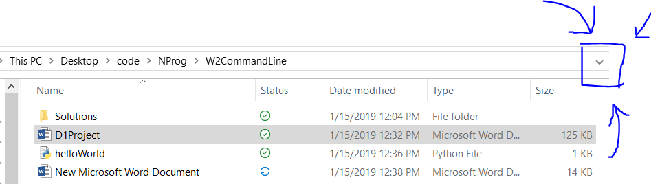

* 1. This should highlight the location of the folder
  2. Press ctrl- c to copy the highlighted text
  3. Go to command prompt and type cd then paste the copied text

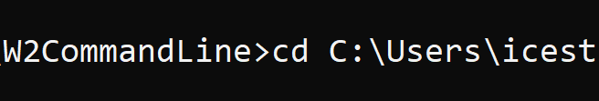

* 1. Press enter. If command prompt doesn’t print a single blank line, try it again
  2. Command prompt should now have the location of the desired folder



* + 1. Type dir and press enter to show the contents of the folder. This should contain a file called helloWorld.py

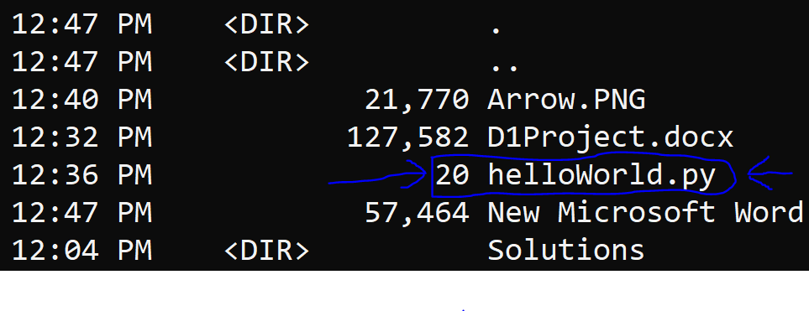

1. Run the python file
   1. In command prompt type python helloWorld.py